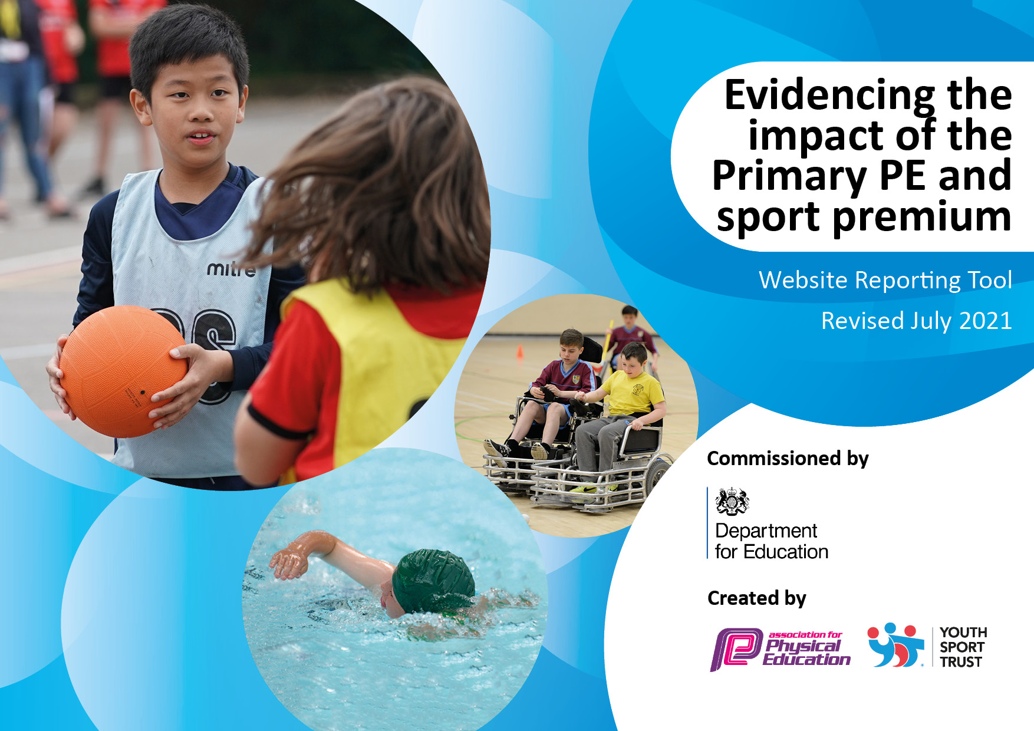
Details with regard to funding
Please complete the table below.

Total amount carried over from 2020/21 | £3412.00
Total amount allocated for 2021/22 | £19,530.00
How much (if any) do you intend to carry over from this total fund into 2022/23? | £2321.00
Total amount allocated for 2021/22 | £22,942.00
Total amount of funding for 2021/22. To be spent and reported on by 31st July 2022. | £22,522.00
Swimming Data
Please report on your Swimming Data below.

Meeting national curriculum requirements for swimming and water safety.  N.B. Complete this section to your best ability. For example you might have practised safe self-rescue techniques on dry land which you can then transfer to the pool when school swimming restarts.  Due to exceptional circumstances priority should be given to ensuring that pupils can perform safe self rescue even if they do not fully meet the first two requirements of the NC programme of study | Due to Covid-19, Eastfield Primary School did not swim in 2020/2021.
What percentage of your current Year 6 cohort swim competently, confidently and proficiently over a distance of at least 25 metres?  N.B. Even though your pupils may swim in another year please report on their attainment on leaving primary school at the end of the summer term 2020.  Please see note above | 73%
What percentage of your current Year 6 cohort use a range of strokes effectively [for example, front crawl, backstroke and breaststroke]?  Please see note above | 69%
What percentage of your current Year 6 cohort perform safe self-rescue in different water-based situations? | 57%
Schools can choose to use the Primary PE and sport premium to provide additional provision for swimming but this must be for activity over and above the national curriculum requirements. Have you used it in this way? | Yes/No

Action Plan and Budget Tracking
Capture your intended annual spend against the 5 key indicators. Clarify the success criteria and evidence of impact that you intend to measure to evaluate for pupils today and for the future.

Academic Year: 2021/22 | Total fund allocated: £22,942.00 | Date Updated:
Key indicator 1: The engagement of all pupils in regular physical activity – Chief Medical Officers guidelines recommend that primary school pupils undertake at least 30 minutes of physical activity a day in school |  |  |  | Percentage of total allocation:
 |  |  |  | 13%
Intent | Implementation |  | Impact
Order and buy new sports equipment to ensure lessons are well resourced and equipment is safe to use. This will enhance the PE provision and the quality of lessons being taught.  Encourage children to meet the required 30 minutes of physical activity during the school day by providing a daily mile track on the field.  Train sports leaders to offer a range of activities during break and lunch times.  Subsidise After School Clubs for children in each year group so they become more active and increase knowledge about sports and confidence. | - Purchase additional resources where required.  - Continue with lunchtime sports activities led by sports coach.  - Sports Leadership opportunities including the Sports Ambassadors programme and playground leadership.  - Train Sports Ambassadors and Sports Leaders.  - Implement the pupil voice with after school clubs selected by the children across the school. | Funding: £3050  £1050  £1000  £1000 | Observations to see the increased changes in pupil’s participation with active lunches and after school clubs.  Children to develop skills, coordination and fitness and to use their skills to coach their peers.  Increased participation in after school clubs has improved confidence of children. | Continue to monitor opportunities during lunch time and to keep the pupil voice at the forefront of the direction of the after school sports offer.  Develop school leaders who can monitor and develop games at play times.
Key indicator 2: The profile of PESSPA being raised across the school as a tool for whole school improvement
 |  |  |  | Percentage of total allocation:
Intent | Implementation |  | Impact | 15%
Raise the profile of Physical Education School Sports and Physical Activity through the introduction of Play Leaders.  Ensure school sport is visible in the school (pupil reward and recognition of pupils in assembly)  Ensure children feel proud to represent Eastfield Primary School.  Technology improved to allow for non-participants to continue to develop subject knowledge. | - Organise school sports days.  - Train Sports Ambassadors and Sports Leaders.  - Promote sporting activity and celebrate achievements through Newsletters, assemblies, notice boards.  - Children to feel proud to represent Eastfield by wearing school clothing.  - iPads to support the technique or children and the ability for children to critique other children. | Funding: £3416  £1000  £344  £2072 | Raise participation in PE and physical activity at play times and after school.  Children are more encouraged to experience a wider range of activities.  Raise the importance of analysis of techniques through the use of technology. | Expand the PE provision using new equipment.  Wear Eastfield personalised tops for sporting competitions.  Monitor and observe the use of technology in PE lessons.

Key indicator 3: Increased confidence, knowledge and skills of all staff in teaching PE and sport |  |  |  |  |  | Percentage of total allocation:
 |  |  |  |  |  | 37%
Intent | Implementation |  |  | Impact
Sports coach to work with staff and provide CPD by increasing confidence and upskilling, improving subject knowledge and ensuring the delivery of high quality lessons.  Online PE planning to improve pitch and expectations within lessons. | - PE Hub to provide relevant units of work, from which class teachers can deliver lessons. Teachers to be given support in their teaching of PE when required.  - Use specialist coach for staff training to increase the knowledge and confidence of staff in delivering PE.  - Purchase quality assured resources to support teachers and support staff.  - Subject Leader to attend relevant sport conferences and network. |  | Funding: £8455  £8,000  £455 | Feedback from teachers from survey helped support CPD. Expert worked alongside staff and pupils to deliver block of lessons. Feedback and observations show that pupils were active and engaged during sessions.  Lesson plans helped staff to deliver well-structured progressive sessions.  Improved quality of teaching and staff confidence when teaching PE. |  | Audit in the Aut term to target areas of development.  Observations and staff feedback to ensure effectiveness.
Key indicator 4: Broader experience of a range of sports and activities offered to all pupils |  |  |  |  |  | Percentage of total allocation:
Intent |  | Implementation |  |  | Impact | 18%
Children have the opportunity to experience a broader range of sports at a discounted rate. Subsidised and in addition to PE lessons.  Provide opportunities to take part in a diverse range of school sport through extra-curricular clubs, competitions and events.  Reduce behaviour incidents and low level disruption at lunchtime with organised games and replenishing equipment.  Provide the opportunity for targeted children to participate in regular exercise to increase resilience and teamwork. | - Provide opportunities by subscribing to, and using, the resources of the BEP trust.  - Continue to employ sports coaches to provide a wider range of opportunities during the school day and after the school day.  - PE coach to target different groups of children to help develop resilience and working within a team. |  | Funding: £4200  £1500  £2000  £700 | Children experience success and enjoyment in different activities. Children developing leadership skills within sessions to help support lessons and play times.  Improved equipment for lessons so pupils have the right equipment for sessions.  Children are excited about sports offer and participating numbers reflect this. |  | Audit equipment, restock where needed and continue to undertake pupil voice at the end of every half term to help guide the after school provision.  Liaise with external agency (BEP) to provide continued after school competitive sporting opportunities.  Continue and grow the after school offer to help broaden the range of sports on offer.

Key indicator 5: Increased participation in competitive sport. |  |  |  | Percentage of total allocation:
Intent | Implementation |  | Impact | 15%
Ensure all children have access to opportunities to participate in additional, inclusive competitive sports.  Provide opportunities for all pupils to challenge themselves through both intra and inter school sport. | - Take part in the BEP competitive sports package. This offers a wide range of sports for children to try and compete in. | Funding: £3500  £3500 | Increased participation in competitive sports.  Sports day and a lunch time Football Tournament offered opportunity for all children to take part in competitive sport in the school day. | Provide after school clubs to encourage competitive sports to take place and give pupils a fair advantage when competing.

Signed off by
Head Teacher: | T . E Gilbert
Date: | 31st July 2022
Subject Leader: | M. Ellis
Date: | 31st July 2022

